EC-231 Operating Systems
BS(CE)-2021
LAB REPORT # 5

Submitted By:
Reg. No. | Name
21-CE-009 | Huzaifa Shahbaz
21-CE-020 | Muhammad Ibthesam
21-CE-021 | Yawar Ali

Department of Computer Engineering
BS Computer Engineering Program HITEC University Taxila
 | Presentation  (Format (0.5) + Title (0.5) +  Conclusion(1) + Procedure(2) + Objective(1)) | Calculation/Coding | Observation/ Program Results | Total
Total | 5 | 5 | 5 | 15
Obtained
___________________________
Lab Instructor.
Engr. Fasih Ahmad

Experiment #5
Setting up environment variables using system calls in Linux.
Objective: The learning objective of this lab is for students to understand how environment variables affect program and system behaviors.

Software Used: Ubuntu

Procedure: Theory: Environment variables are a set of dynamic named values that can affect the way running processes will behave on a computer. They are used by most operating systems since they were introduced to Unix in 1979. Although environment variables affect program behaviors, how they achieve that is not well understood by many programmers. As a result, if a program uses environment variables, but the programmer does not know that they are used, the program may have vulnerabilities. Environment variables allow you to customize how the system works and the behavior of the applications on the system. For example, the environment variable can store information about the default text editor or browser, the path to executable files, or the system locale and keyboard layout settings. List Environment Variables: The most used command to displays the environment variables is printenv. If the name of the variable is passed as an argument to the command, only the value of that variable is displayed. If no argument is specified, printenv prints a list of all environment variables, one variable per line. Manipulating Environment Variables using C program: We study the commands that can be used to set and unset environment variables. Now we use multiple system calls to get or set the Environment Variables. getenv(): The getenv() function searches the environment list to find the environment variable name, and returns a pointer to the corresponding value string. Function prototype: char * getenv(const char *name); Function parameters: 1:Name is the name of the environment variable you want to get return value: 2:The call successfully returns a pointer to value 3:Call failed to return NULL Putenv(): The putenv function is used to add or modify environment variables to the environment table. If there is no name environment variable in the environment table, add the environment variable; if the environment variable has name in the environment table, delete the previous value and then modify it to the new value. Function prototype: int putenv(char * string); Function parameters: 1:String is a pointer to an environment variable, where the environment variable must be given as "name=value" return value: 1:The call returns successfully 0 2:Returns a non-zero value when the call fails Setenv(): The setenv function is similar to the putenv function and can be used to add or modify environment Function prototype: int setenv(const char *name, const char *value, int overwrite); Function parameters: 1:Name is the environment variable name 2:Value is the value of the environment variable 3:Overwrite: Overwrite option, when name exists in the environment table, if the value of overwrite is 0, the value of name is not modified; if the value of overwrite is non-zero, the value of name is modified; if there is no such environment variable, This environment variable is added regardless of the value of overwrite. The environment variable of the shell process cannot be added or modified by this function, or the environment variable set by the setenv function is only valid in this process, and it is valid in this execution. If the setenv function is executed when the program is run once, the program is run again after the process terminates. The last setting is invalid, and the last set environment variable cannot be read. return value: 1:The call returns successfully 0 2:Return non-zero when the call fails Although the putenv function and the setenv function are similar in function, there are still differences in the implementation of these two functions. The differences are as follows: Putenv function: The putenv function fills in the parameter string directly into the environment table, and no longer allocates memory for the string "name=value". If the string is defined in a function, after the function is called, the content pointed to by string may be released, and the value of the name environment variable cannot be found. Setenv function: The setenv function is different from the putenv function in that it copies a copy of the contents pointed to by name and value and allocates memory for it, forming a string of "name=value" and writing its address to the environment table. So there will be no case of putenv above, even if the function returns, the content pointed to by name and value is released, there is still a copy.

Tasks
Task 1: Execute all mentioned shell commands to print/set environment variables. CODE:
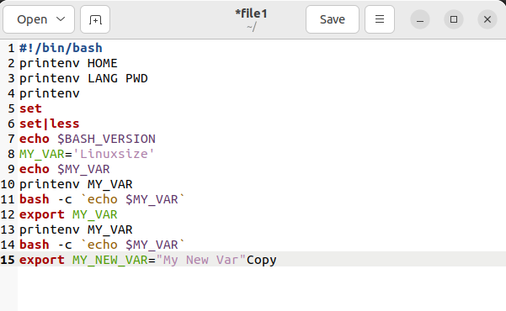

Task 2: Run above example code and change the size of history to 100. CODE: 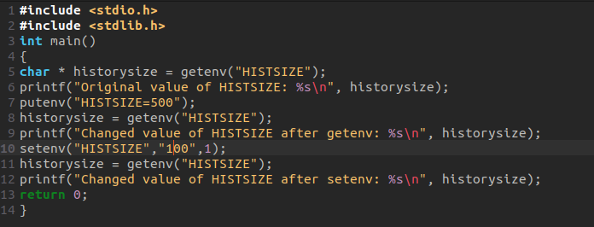
OUTPUT: 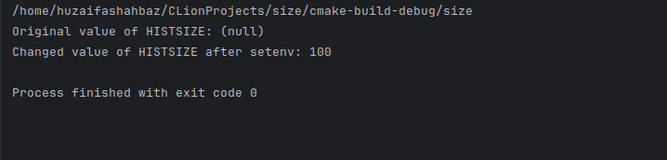
Task 3: Write a c program to get the system username using getenv() and update it to your surname using putenv() , now print the updated username and set it back to original username using setenv() system call. CODE: 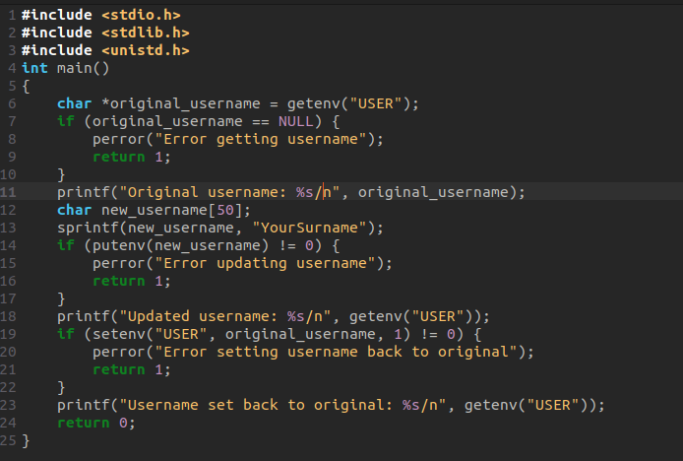 OUTPUT: 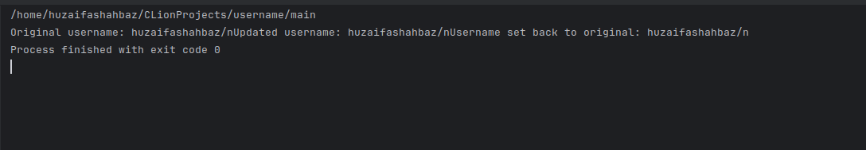

Conclusion: In conclusion, we had studied the Setting up environment variables using system calls in Linux and also we know the c language in ubuntu operating system and also working function.

